**18 Cost-effectiveness of seasonal influenza vaccination**

**Overview**

The purpose of this practical is to show you what types of data are needed to estimate the incremental cost-effectiveness ratio (ICER) of introducing a vaccination program, and to carry out probabilistic sensitivity analysis (PSA) on the results.

**PART Ⅰ: Modelling seasonal influenza**

* Dynamic model of infectious disease

$$\frac{dS_{y}(t)}{dt}=-β_{yy}I_{y}\left(t\right)S_{y}\left(t\right)-β_{yo}I_{o}\left(t\right)S_{y}(t)$$

$$\frac{dI_{y}(t)}{dt}=β_{yy}I_{y}\left(t\right)S_{y}\left(t\right)+β_{yo}I_{o}\left(t\right)S_{y}\left(t\right)-γI_{y}(t)$$

$$\frac{dR_{y}(t)}{dt}=γI_{y}(t)$$

$$\frac{dS_{o}(t)}{dt}=-β_{oy}I_{y}\left(t\right)S_{o}\left(t\right)-β_{oo}I_{o}\left(t\right)S_{o}(t)$$

$$\frac{dI_{o}(t)}{dt}=β_{oy}I_{y}\left(t\right)S_{o}\left(t\right)+β_{oo}I_{o}\left(t\right)S_{o}\left(t\right)-γI_{o}(t)$$

$$\frac{dR_{o}(t)}{dt}=γI_{o}(t)$$

Subscript $y$ and $o$ denote children and adults, respectively.

* Vaccine strategy A and Vaccine strategy B

|  |  |  |
| --- | --- | --- |
|  | Coverage | |
| Children | Adults |
| Strategy A | 50% | 0% |
| Strategy B | 25% | 25% |

* Parameters and values used in the model

|  |  |  |
| --- | --- | --- |
| **Parameter** | **Description** | **Value** |
| $$N_{y}$$ | Total number of children | 10000 |
| $$p_{y}$$ | Proportion of immune children | 0.25 |
|  | Proportion of clinical case among children | 0.4 |
|  | Case fatality rate of children | 0.0001 |
| $$N_{o}$$ | Total number of adults | 40000 |
| $$p_{o}$$ | Proportion of immune adults | 0.4 |
|  | Proportion of clinical case among adults | 0.4 |
|  | Case fatality rate of adults | 0.0002 |
|  | Transmission coefficient | 0.55 |
|  | Mixing matrix | $$\left[\begin{matrix}1 & 0.15 \\ 0.15 & 0.8\end{matrix}\right]$$ |
| $$\left[\begin{matrix}β_{yy} & β_{yo} \\ β_{oy} & β_{oo}\end{matrix}\right]$$ | WAIFW  = Transmission coefficient $×$ Mixing matrix ./ $\left[\begin{matrix}N_{y} & N_{o} \\ N_{y} & N_{o}\end{matrix}\right]$.  ./ means pointwise division | $$\left[\begin{matrix}0.000055 & 0.00002 \\ 0.000008 & 0.00011\end{matrix}\right]$$ |
| $$γ$$ | Recovery rate | 1/3 |
| $$e$$ | Vaccine efficacy | 0.4 |
| $$c_{y}$$ | Vaccine coverage for children |  |
| $$c_{o}$$ | Vaccine coverage for adults |  |

|  |  |  |
| --- | --- | --- |
| **State** | **Description** | **Value** |
| $$R_{y}(0)$$ | Initial value of recovered children  = ${p_{y}N}_{y}+\left(1-p_{y}\right)N_{y}c_{y}e$ |  |
| $$I_{y}(0)$$ | Initial value of infectious children | 5 |
| $$S_{y}(0)$$ | Initial value of susceptible children  = $N_{y}-R_{y}\left(0\right)-I_{y}(0)$ |  |
| $$R_{o}(0)$$ | Initial value of recovered adults  = ${p_{o}N}_{o}+\left(1-p_{o}\right)N_{o}c_{o}e$ |  |
| $$I_{o}(0)$$ | Initial value of infectious adults | 5 |
| $$S_{o}(0)$$ | Initial value of susceptible adults  = |  |

|  |  |
| --- | --- |
| **Use forward Euler method to solve the model** | |
| Initial time | 0 |
| Terminal time | 200 |
| Time step size | 0.2 |

|  |  |
| --- | --- |
| **Cost and QALY** | **Value** |
| Cost per vaccination | 8 |
| Cost per clinical case | 12 |
| QALY loss per clinical case | 0.005 |
| QALY loss per death | 30 |

1. Calculates two clinical outcomes (the number of clinical cases and deaths) under no vaccine, “Vaccine strategy A”, and “Vaccine strategy B”.

|  |  |  |  |
| --- | --- | --- | --- |
|  | No vaccination | Strategy A | Strategy B |
| Number of clinical cases | 3586.8 | 1090.9 | 1923.5 |
| Number of deaths | 0.58507 | 0.18549 | 0.30746 |

1. Which vaccine strategy has the greatest impact on influenza infections? Why?

Strategy A has the greatest impact on influenza infections. Proportion of immune children is 0.25 and the proportion of immune adults is 0.4. The proportion of immune is smaller for the children. Also, if you see the mixing matrix, $\left[\begin{matrix}1 & 0.15 \\ 0.15 & 0.8\end{matrix}\right]$, the contact between children is more frequent than the contact between adults. The strategy A vaccine coverage for child is 50% and the strategy B vaccine coverage for child is 25%. Strategy A concentrates more on children, so it has greater impact than strategy B. The number of clinical cases prevented is higher in strategy A. Adding to that, the number of deaths prevented is higher in strategy A.

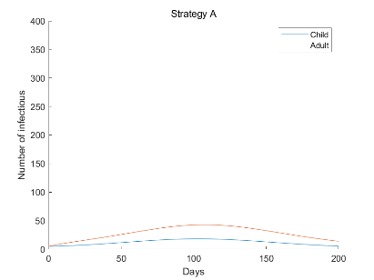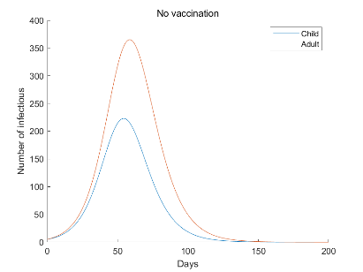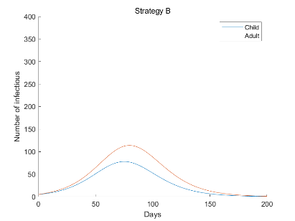

1. The QALY loss associated with an influenza death is set to 30. How do you think such a number may be estimated? Can you think of any reason why having a single number for this value may not always be a good idea?

Considering the average life expectancy, if the person is healthy, the person could live 30 but because of the death by influenza, the person lost 30 years. Thus, the QALY loss associated with an influenza death is estimated to be 30.

1) Child and adult have the same QALY loss 30 so it may be not reasonable enough. Children’s QALY loss should be greater than adults.

2) We should consider discounting for QALY loss. Then, it will be smaller than 30.

1. Fill in the following table and cost-effectiveness plane:

|  |  |  |
| --- | --- | --- |
| Differences | No vaccine to A | No vaccine to B |
| Clinical cases prevented | 2495.9 | 1663.3 |
| Deaths prevented | 0.39958 | 0.27761 |
| Number vaccinated | 3750 | 7875 |
| Vaccine costs | 30000 | 63000 |
| Treatment costs | -29951 | -19960 |
| Total costs | 48.661 | 43040 |
| QALYs gained by preventing cases | 12.48 | 8.3165 |
| QALYs gained by preventing deaths | 11.987 | 8.3283 |
| Total QALYs gained | 24.467 | 16.645 |
| Incremental cost per case prevented | 0.019496 | 25.877 |
| Incremental cost per death prevented | 121.78 | 1.5504e+05 |
| Incremental cost per QALY gained | 1.9888 | 2585.8 |

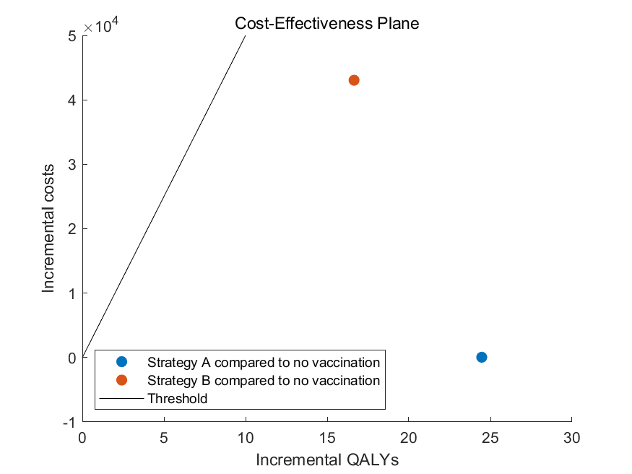

1. Suppose this model is being used to inform vaccination decisions in a country with a threshold of £5,000 per QALY gained for a health technology to be cost-effective. Based on the results of your calculation, what would you advise decision makers to do?

Both strategies A and B are cost-effective compared to no vaccination, but strategy A is more effective than strategy B. Therefore, vaccination under strategy A would be recommended.

**PART Ⅱ: Sensitivity analysis**

In the previous cost-effectiveness calculation, we assumed that the economic parameters (costs and QALY losses) were known precisely. In this part, we will estimate the impact of uncertainty on the cost-effectiveness of “Vaccine strategy A” (compared to no vaccination) using both one-way and probabilistic sensitivity analysis.

1. Change the value of the following parameters by ±25%. What happens to the ICER in each case?

|  |  |  |  |  |
| --- | --- | --- | --- | --- |
| Parameter | Lower  value | ICER | Upper  value | ICER |
| Transmission coefficient child-child | 0.4125 | 37477 | 0.6875 | 521.63 |
| Case-fatality risk in children | 0.0075% | 2.0515 | 0.0125% | 1.9299 |
| Cost per clinical case | 9 | 308.02 | 15 | -304.05 |

1. Which parameter that you varied has the largest impact on the ICER? In what way does (i) decreasing it by 25% and (ii) increasing it by 25% alter the ICER? Why?

Strategy A compared to no vaccination, the base ICER is 1.9888. The ICER increased when the transmission coefficient decreased or increased by 25%. Varying transmission coefficient child-child has the largest impact on the ICER. Usually, the transmission coefficient is the most sensitive. It is because this parameter affects the direct cause of disease.

1. Decreasing the transmission coefficient will decrease the amount of infection for vaccination to prevent, so the incremental QALYs will be reduced, and hence ICER will be increased.
2. Increasing the transmission coefficient make it harder for vaccination to prevent transmission, so the incremental costs will increase due to the treatment costs and the incremental QALYs will decrease, which result in higher ICER than the base case.
3. For PSA, the maximum and minimum value assumed for the distribution of the four economic parameters. Assuming that they are uniformly distributed, sample 100 values from these distributions and run the scenario to fill in the table below and cost-effectiveness plane as in PARTⅠQ4. Use this to calculate the mean and 95% interval of the ICER.

|  |  |  |  |  |
| --- | --- | --- | --- | --- |
|  | Cost per fully vaccinated person | Cost per clinical case | QALY loss per clinical case | QALY loss per death |
| Minimum | 4 | 6 | 0.0025 | 20 |
| Maximum | 12 | 18 | 0.0075 | 40 |

|  |  |  |  |  |  |  |  |  |  |  |  |
| --- | --- | --- | --- | --- | --- | --- | --- | --- | --- | --- | --- |
|  | Cost per fully vaccinated person | Cost per clinical case | QALY loss per clinical case | QALY loss per death | No vaccination | | Vaccination A | | Difference | | |
| Net QALYs lost | Net cost | Net QALYs lost | Net cost | Incremental QALYs | Incremental costs | ICER |
| 1 | 10.518 | 7.9462 | 0.0057216 | 21.192 | 32.921 | 28502 | 10.173 | 48110 | 22.749 | 19608 | 861.95 |
| 2 | 11.246 | 15.531 | 0.004393 | 33.639 | 35.439 | 55708 | 11.032 | 59117 | 24.407 | 3408.2 | 139.64 |
| 3 | 5.0159 | 9.7346 | 0.0065579 | 20.849 | 35.72 | 34916 | 11.021 | 29429 | 24.699 | -5487.4 | -222.17 |
| … |  |  |  |  |  |  |  |  |  |  |  |
| 100 | 6.697 | 15.538 | 0.0048554 | 23.575 | 31.209 | 55732 | 9.6697 | 42064 | 21.539 | -13668 | -634.58 |

ICER mean: 80.734160

ICER 95% interval: (-1091.679756, 1215.302417)

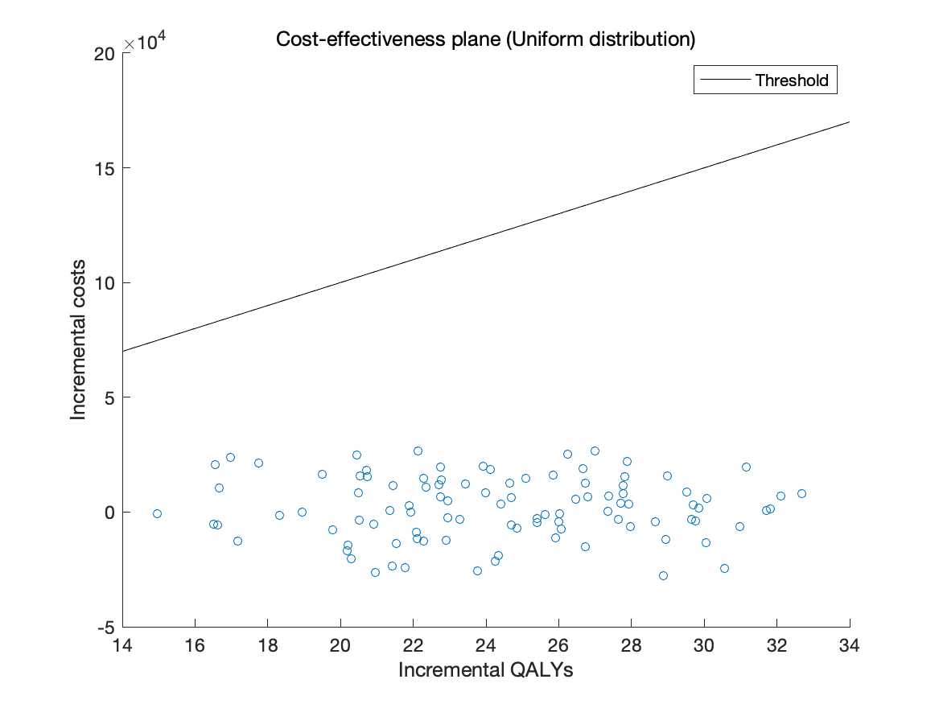

1. Do you think a different type of distribution may be better than a uniform distribution? How could it be implemented? Repeat Q3 using other choice.

It depends on the amount of information we have about the parameter distribution. Therefore, in choosing the distribution of a parameter, there is no absolutely standard.

You can use proper built-in functions for sampling from normal or lognormal distribution.

|  |  |  |  |
| --- | --- | --- | --- |
|  | Mean | 95% interval left | 95% interval right |
| Uniform | 80.734160 | -1091.679756 | 1215.302417 |
| Normal | 5.875486 | -325.120120 | 303.031291 |
| Lognormal | -361.570222 | -7949.058474 | 5083.886473 |

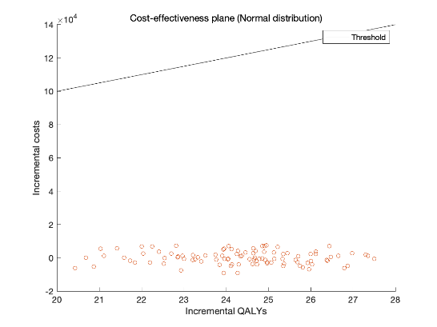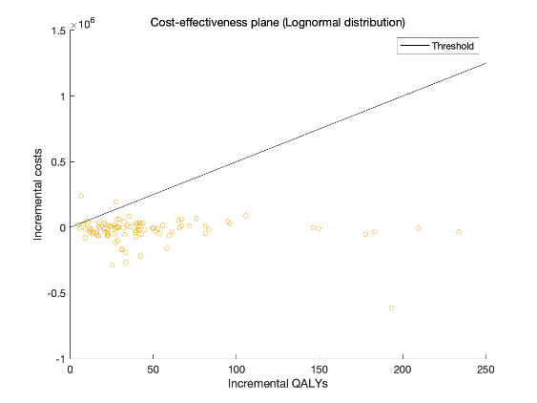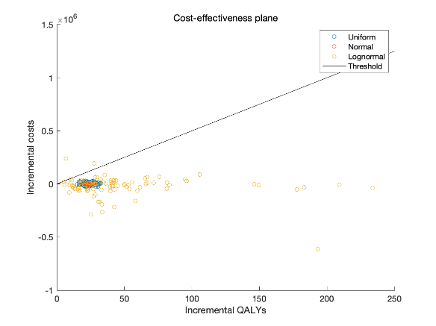

1. How certain are you that the advice you gave in PARTⅠQ5 above is correct?

When in the uniform and normal distribution, we can be sure that Strategy A is effective. In the case of log-normal, we also can be sure, but, there are very few chances that the strategy A will not be effective.

**PART Ⅲ: Comparing the results to those obtained using a static model**

Many cost-effectiveness analyses of vaccination and other infectious disease interventions are

based on static models that do not take into account transmission. As a result, these often underestimate the impact that vaccination will have. To see the difference between static and dynamic models, we will construct a static model which is equivalent to the dynamic model except that it does not take into account transmission of influenza.

The number of clinical infections in the “No vaccination” strategy is assumed to be identical to the number found in the dynamic model. In the “Vaccination strategy A”, use the following formula to calculate the number of clinical infections and use an equivalent formula to calculate the number of deaths:

* Number of clinical infections with vaccination in children =

Number of clinical infections without vaccination in children

x (1 – Vaccine efficacy in children x Vaccine coverage in children)

*The key difference is that this only takes into account the direct effect of vaccine protection on people who are vaccinated, and not prevention of onward transmission from them (herd protection).

1. Compare the ICERs you obtain using a static and a dynamic model. What do you notice? What does the difference tell you?

|  |  |  |  |
| --- | --- | --- | --- |
|  | No vaccination | Strategy A | Difference |
| Clinical cases | 3586.8 | 3322.2 | 264.58 |
| Deaths | 0.58507 | 0.55861 | 0.026458 |
| Number vaccinated |  | 3750 | 3750 |
| Vaccine costs |  | 30000 | 30000 |
| Treatment costs | 43042 | 39867 | -3175 |
| Total costs | 43042 | 69867 | 26825 |
| QALY loss for clinical cases | 17.934 | 16.611 | 1.3229 |
| QALY loss for deaths | 17.552 | 16.758 | 0.79375 |
| Total QALY loss | 35.486 | 33.37 | 2.1167 |
| Incremental cost per case prevented |  |  | 101.39 |
| Incremental cost per death |  |  | 1013855 |
| Incremental cost per QALY gained |  |  | 12673 |

The estimated ICER in the static model is larger than the ICER from the dynamic model. Since the static model cannot describe the transmission dynamic, it underestimated clinical cases prevented by vaccination and therefore overestimated ICER value.